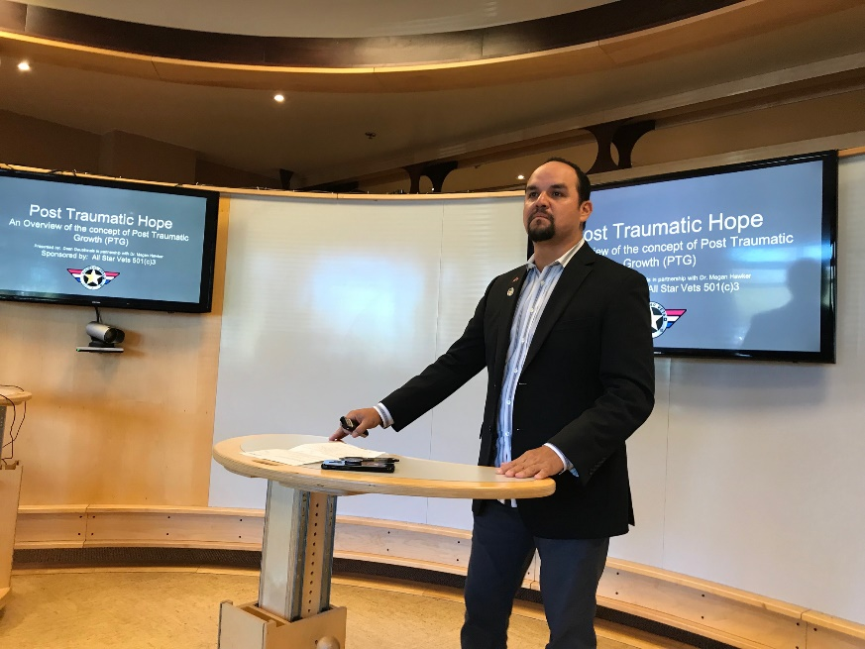
Dean Dauphinais, Owner/Operator, Native Eco Solutions, Inc., Founder/Director, All Star Vets, Marine Veteran, Enrolled Member Turtle Mt. Band of Chippewa Indians/Spirit Lake Dakota

2505 Via Astuto, Carlsbad, CA 92010 * Mobile: (760) 889-9481

LinkedIN: https://www.linkedin.com/in/dean-dauphinais-a7947435/

Social: https://www.facebook.com/nativeecosolutions

Email: dean@nativeecsosolutions.com

Background

Dean Dauphinais was born and raised on the Spirit Lake Nation reservation located in central North Dakota. Dean is an enrolled member of the Turtle Mt. Band of Chippewa Indians. Representing both his Objibwe and Dakota heritage, Dean continues to strive for solutions-focused change in Indian country and within the Veterans/Warrior communities.

Dean is a graduate of The University of North Dakota, and Veteran of the United States Marine Corps.

Leadership

Dean is a seasoned leader and manager with 20 years of experience in a variety of professional settings and brings a wealth of knowledge in the areas of Veterans Services, Federal grants & contracts, community organizing, systems integration, quality assurance, safety, information management, donor relations, public relations, project management, and post-traumatic growth.

Founder

Dean founded All Star Vets in May of 2016 to make a positive impact in military and veterans services focusing on holistic healing modalities, sports and recreation therapy, active lifestyle, healthy nutrition, education, leadership, community engagement, and patriotism.

Veterans Advocacy/Nonprofit Leadership

Dean has served Veterans in the North San Diego County since 2009 most notably as an employee of Interfaith Community Services where he served as a case manager, program manager and the Director of Veterans Services. This role exposed Dean to the many socioeconomic problems that we have in our military and Veteran communities especially within the under-served populations such as homeless, at-risk of homeless, unemployed, under-employed, minorities etc.

North County Veterans Stand Down (Founding Board Member)
Dean has been involved as one of the founding board members of North County Stand Down where he served as the Director of Medical and Social Services to provide homeless veterans specifically located in the North San Diego County region, easier access to transitional housing, employment, VA Benefits, homeless-prevention services along with other much needed services and supports. (2016-2017)
Marine Corps Veteran Ball (Founding Committee member)
Dean was a part of the committee that introduced the Marine Corps Birthday Ball to the San Diego Community to give area Marine Veterans a gathering place to continue celebrating traditions and building camaraderie amongst Marine Corps Veterans. (2017)
American Legion Baseball (Committee Member)
As an active member of American Legion Post 416 Dean served on the committee that successfully revitalized American Legion Baseball in San Diego as the committee organized a 13-team league culminating in a District tournament which ended with the champion of the tourney playing in Yountville, CA for the California American Legion Baseball State Championships. (2017-2018)
Randy Jones Foundation (Advisory Board Member) https://www.randyjonesfoundation.com/board-of-directors.html
As an Advisory Board member for Randy Jones Foundation, Dean helped to shape and inform the Randy Jones Foundation Scholarship Fund which offers scholarships to children of veterans or active duty members who need financial assistance to pay for travel ball costs, nutrition, personal training and other things that help the student athlete to excel in their sport of endeavor.
Memberships
American Indian Chamber of Commerce of California (AICCC) http://www.aicccal.org/default.html
To provide Opportunities for networking and support of American Indian business people in California. To Provide a mentor's environment for those individuals beginning new endeavors and establish a vehicle for education, networking and growth opportunities.
Minnesota American Indian Business Chamber (MAICC) https://www.maicc.org/
To promote, advocate, and create economic prosperity on behalf of American Indian businesses, organizations, professionals, and tribal enterprises in a global market.
National Congress of American Indians (NCAI) https://ncai.org/about-ncai/mission-history
- Protect and enhance treaty and sovereign rights
- Secure our traditional laws, cultures, and ways of life for our descendants
- Promote a common understanding of the rightful place of tribes in the family of American governments
- Improve the quality of life for Native communities and peoples
Native Eco Solutions, Inc. (Owner/Operator)
Taking knowledge and experience gained from 20 years of professional experience on a myriad of socio-economic issues, Dean decided to use that experience to create his own opportunities as an entrepreneur.
The vision for Native Eco Solutions, Inc., is to connect tribal communities with opportunities to improve the quality of life of their people by inspiring collaboration in Indian Country and matching Indigenous values with strong business fundamentals to improve tribal communities.

As Native Americans and as Warriors, we are the protectors of our lands, we are the original environmentalists of this land, and we at Native Eco Solutions, Inc. look forward to continuing on in this spirit of proper stewardship, respect of our land and resources, resiliency and Native American self-sufficiency.
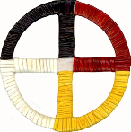
~Dean Dauphinais, President & CEO~
“Education is your greatest weapon…study, learn, help one another always.” Chief Plenty Coups (Apsaaloke)

